School Of W.E.S.H Application Form:
Levels of membership:
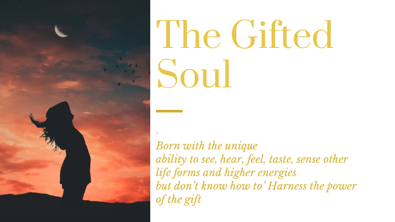

Hello, thank you for your interest to join the School of Wisdom, Enlightenment and Self-Healing – W.E.S.H.

The School of W.E.S.H is a legacy to the life of a young woman so, so tormented by her ability to see the aura, energy bodies of everyone she met that she made a choice to leave this world. On the day we cast her ashes out the sea she came to me as I walked back to my car and said she wanted to ask something of me. I said anything for you to which she said “I want to ask you to look after the other people who are like me so that they can live their life in harmony with their gifts/curse”.

The School Of W.E.S.H provides 2 levels of learning in a sacred, safe space.
The Gifted Soul: You arrived into this world with natural abilities to see, hear and or feel things that can’t be seen by the human eye. This gift can be very disturbing and cause immense distress for some as it did for the young lady to whom the School is a legacy.
There is no question of uncertainty you know you are gifted whether you use the gifts or not.
Not everyone must be of service with their gifts. It is often just enough to know how to live a balanced life with your gifts.

For you is The Gifted Soul membership. Please apply here.

The Gifted Soul
Your details please:
Name: ______________________________________________________
Email: ______________________________________________________
Phone: _____________________________________________________
Age: _______________________________________________________
M/F: _______________________________________________________

- The Gifted Soul: (Please share what your gift/s are)

- Please share what you experience through your gift/s:

- Please share what challenges you have with being Gifted:

- What would you like to be able to do with your gifts?

- How would you like to entwine your gifts with your life?

- How would you like to be of service to mankind through your gifts?

- Anything else you might like share?

--- Please email the accomplished form to support@healwithgwenda.com ---

