School Of W.E.S.H Application Form
Levels of membership:
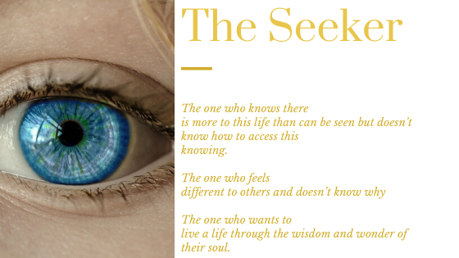

Hello, thank you for your interest to join the School of Wisdom, Enlightenment and Self-Healing – W.E.S.H.
The School of W.E.S.H is a legacy to the life of a young woman so, so tormented by her ability to see the aura, energy bodies of everyone she met that she made a choice to leave this world. On the day we cast her ashes out the sea she came to me as I walked back to my car and said she wanted to ask something of me. I said anything for you to which she said “I want to ask you to look after the other people who are like me so that they can live their life in harmony with their gifts/curse”.
Over the course of years of my work in service to mankind thought the guidance of the ALMIGHTY Divine, which for me is GOD. I have come to work with people with who are what I call Seekers, in that they know there is more to this life than can be seen with the eyes or touched with the hand. Most often the Seeker feels that they are different to most people but don’t know how or why they feel this way.
They have a yearning and a calling that comes from deep within but to what they do not understand only to know that they want to know more about things that can’t be seen or explained so it is thought anyway.
Often the Seeker has embarked on self-learning courses, taken up mediation yoga, prayer, seeking the answers to the feeling they have that simply won’t be quieted, and yet they find that after doing many of these practices or learning they are still Seeking and still not knowing what it is they seek.

The School Of W.E.S.H provides 2 levels of learning in a scared, safe space.
The Seeker: Is for you if you want to finally feel that you have the missing piece of the puzzle. To know how to hear the messages from your soul and how to live an enlightened conscious life one that is fulfilling and powerful. Your heart will be at peace and your mind will be harnessed through your expansion of consciousness.
Through this program you are sure to find that you become much more in tune with your natural 6th sense which is the way to live a more awakened and peaceful life in this world.

For you is The Seeker Membership please apply here.

The Seeker
Your details please:
Name: ______________________________________________________
Email: ______________________________________________________
Phone: _____________________________________________________
Age: _______________________________________________________
M/F: _______________________________________________________

- Please share your experience of feeling somewhat different to other people:

- Please share what courses you have done:

- Please tell us about any daily practices you use:

- Anything else you would like to ask or share?

--- Please email the accomplished form to support@healwithgwenda.com ---

